A000-Eur-Norway-runic calendar-Fasti Danici-1643

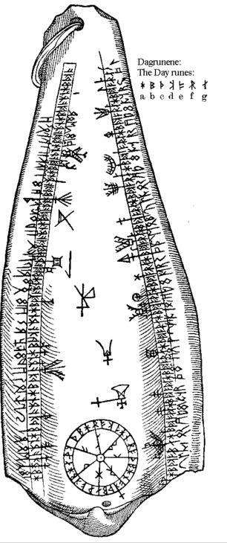

**Viking Runic Lunar Calendar**   
18 x 7.5 cm (7 x 3"), 15 mm thickness (half inch)  
  
Hand made reproduction of Worm’s Norwegian runic calendar described in his book Fasti Danici dating back to 1643. The drawing only shows the winter season lasting from 14 October to 13 April. The summer season on the other side was never copied, and both the pendant and the calendar have unfortunately been lost.   
  
Although contemporary Scandinavian sources for the Viking Age are few, there are indications that the Vikings probably divided the year into moon phases and only two seasons: Summer and winter.   
  
The Vikings did not use exact years to date events, a so-called absolute chronology. Instead, they used a relative chronology with reference to the number of years after important events. One could for example date the year by saying “five winters after the Battle of Svolder”.   
  
As far as we know, the Icelander Ari “the Wise” Þorgilsson was the first who in the early 1100s tried to convert the Norse time entries into an absolute European chronology.   
  
The Viking calendar reflected the seasons: How high the sun was in the sky, access to food and fertility. The year was divided into two equally long periods – summer and winter. A person’s age was counted in the number of winters he had lived. This may indicate that “New Year” was on 14 April, i.e. the first day of summer.   
  
The year was divided into moon phases – from new moon to new moon or full moon to full moon. The counting of days has probably not been particularly accurate: The Scandinavia nights are so bright that it is almost impossible to spot the moon.   
  
The darkest period was named “Skammdegí” (the Dark Days) and the year’s brightest period “Nóttleysa”, meaning “insomnia” that many Scandinavians still experience today.   
  
The winter months are Gormánuður, Ýlir, Mörsugur, Þorri, Goa and Einmánuður.   
  
The summer months are Harpa, Skerpla, Sólmánuður, Heyannir, Tvímánuður and Haustmánuður.